Company Representative: Please customize this letter by putting your Company Name and Employee Access Code below. Your unique Code was sent to you in your original registration approval email. If you no longer have access to your Code, please send a request to Registrations@funex.com to receive your Code again. Then, simply Email the below letter to all employees, or post on your intranet. Your job is done! Thank you!

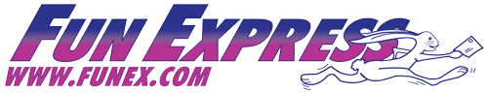

To All Employees of {Put your Company Name here}

Important Employee Access Code (EAC): {Put your Code here}

Reminder: You are all eligible to take advantage of our Employee Benefit Program with Fun Express! As an employee, you and your family can save up to 55% on southern California’s best family entertainment!

Fun Express is California’s largest provider of discount entertainment programs. They will provide this benefit for us! Fun Express has discount tickets to more than 50 southern California attractions including Universal Studios Hollywood, Knott’s Berry Farm, SeaWorld, Legoland, Dinner Shows, Movie Theatres, Water Parks, and much more! On Funex.com, most tickets can be instantly Emailed to you 24 hours a day! You can also order tickets by phone during normal business hours at (949)367-1900.

If you haven’t already done so and you would like to take advantage of this great benefit, you can simply go to FunEx.com and click “Register”. There you can sign up as an Employee of our company by using our Company Employee Access Code (EAC) provided above.

Fun Express has a processing fee of $4 per attraction (NOT per ticket). There is no tax or additional fees on your order. If you have any questions, you may contact Fun Express directly at (949)367-1900.

Please check out FunEx.com for current discount tickets today and start having FUN!!

Thank you!

